

**Fundamental of programming**

**Name: M.Yahya Chand**

**Roll#: 456727**

**Section: ME-15B**

**SUBMITTED TO: SIR. AFFAN**

**Task#1:**

#include <iostream>

using namespace std;

int main() {

/* int a=0,b=0;

cout<<"enter the last number=";

cin>>b;

cout<<"enter the FIRST number=";

cin>>a;

for(int i=a ;i<=b;i++)

{

cout<<"a= "<<a<<endl;

a+=i; }

return 0; }

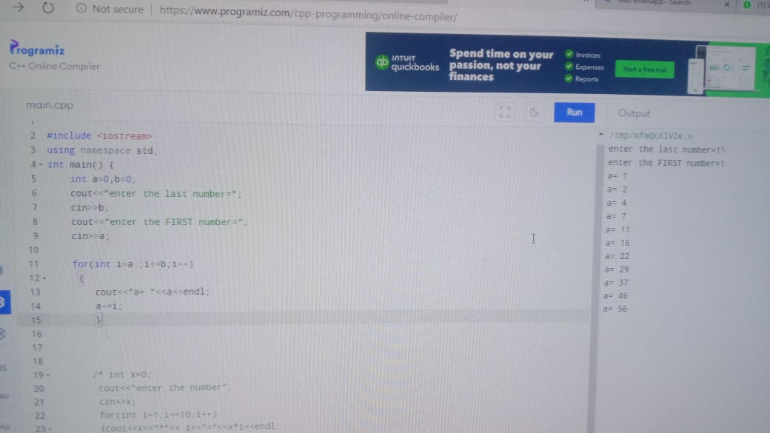

**Task #2**

#include<iostream>

Using namespace std;

Int main()

{ int x=0;

cout<<"enter the number";

cin>>x;

for(int i=1;i<=10;i++)

{cout<<x<<"*"<< i<<"="<<x*i<<endl;

}

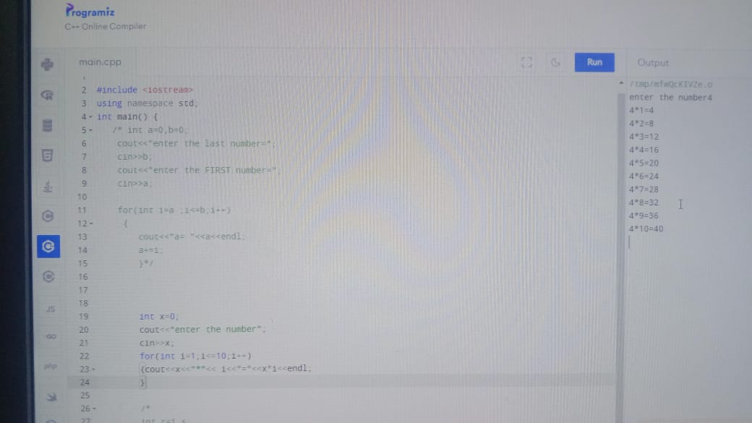

**Task #3:**

#include<iostream>

Using namespace std;

Int main(){

int r=1,s;

cout<<"factorial of number=";

cin>>s;

for(int i=1;i<=s;i++)

{ r*=i;

cout<<s<<"!="<<r<<endl;

}

return 0;

}

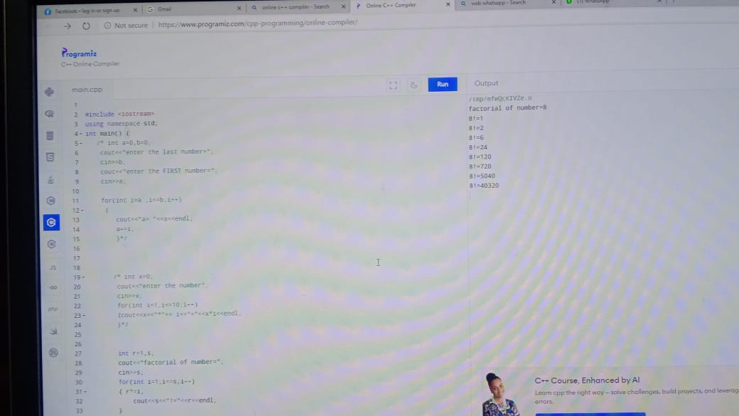

**Task#4:**

#include<iostream>

Using namespace std;

Int main()

{

int x,y,z,w;

cout<<"enter the starting 2 values:"<<endl<<"value 1=";

cin>>x;

cout<<endl<<"value 2=";

cin>>y;

cout<<endl<<"the sequence must end at what value= ";

cin>>z;

cout<<x<<endl<<y<<endl;

for(int i=1;i<=z-1;i++)

{w=x+y;

x=y;

y=w;

cout<<w<<endl;

}

return 0;

}

